**Project Proposal**



**Project Name:** BCD Carpentry Project

**Project Code:** BCD1-0117

**Module Code:** IT7x01

**Prepared by:** Tao Sun, Damian Tait, Konark Bhurke,

**Proposal Submission Date:** 10 March 2017

Contents

**1.** **Assigned Academic Supervisor** 3

**2.** **Approval Date** 3

**3.** **Approver Signature** 3

**4.** **Project Type** 3

**5.** **Project Client** 3

**6.** **End-Users** 3

**7.** **Objective of the Project** 3

**8.** **Scope of the Project** 3

**9.** **Historical information/Background** 4

**10.** **Project Plan** 6

**11.** **Communication plan** 7

**12.** **Methodology** 7

**13.** **Project Budget** 7

**14.** **Project Risk Analysis** 8

**15.** **Skills Analysis** 9

**15.1.** **Team members’ skills** 9

**15.2.** **Skills needed in the project** 9

**15.3.** **Training plan** 9

**16.** **Initial Consultation** 10

**17.** **Project Product Assessment Criteria** 11

**18.** **Documentation Assessment Criteria** 12

**19.** **Project Iterations** 13

**19.1.** **Iteration 1** 13

**19.2.** **Iteration 2** 13

**19.3.** **Iteration 3** 14

**19.4.** **Iteration 4** 15

**20.** **Project Agreements** 16

**21.** **Group Timetable** 16

# **Assigned Academic Supervisor**

**Name:** Sunil Bedi;

**Mobile Phone:** (021) 220-0777;

**Email:** sunil.bedi@whitireia.ac.nz;

# **Approval Date**

# **Approver Signature**

# **Project Type**

Database design & implementation;

Front end development;

# **Project Client**

**Name:** Nicole Moloney;

**Role:** BCD Administrator;

**Phone:** (021) 178-1696;

**Email:** admin@bcd.kiwi.nz;

# **End-Users**

The end-user is same as the project client.

# **Objective of the Project**

The aim of the client is to implement an HRMS (Human Resource Management System) in order to simplify her operation, relieve the workload and help the administrator to manage documents efficiently.

This semester the project team will focus on the design and implementation of the database for the HRMS. Some (not all of the functions) basic, frequently-used functions and simple UIs will be developed.

# **Scope of the Project**

The product of this project should be delivered to the client before 2nd June 2017. By the end of this project, the team should complete the following tasks:

* Completing the collection of requirements;
* Completing the analysis of requirements;
* Producing requirements documentation;
* Completing the design of database;
* Producing database design documents (ERD diagrams);
* Create the database;
* Completing the development of basic functions and simple UIs of the HRMS (further discussion with the client regarding the details of the function’s scope is needed);
* Completing the test of the system;
* Producing the test report;
* Completing the deployment of the system;
* Producing the deployment report.

# **Historical information/Background**

BCD Carpentry was founded in 2008, and has been expanded to a multi cultured medium sized business now. With regard to its human resources management, all the work is conducted with the help of MS office software such as Word or Excel spreadsheet. There is no other special management software or system to help the Administrator’s work; therefore, they have an inefficient way of organising staff and budget-related details. To resolve these problems listed above and improve the efficiency, BCD Carpentry needs an HRMS imminently which can manage all these information above with a database system.

Due to the limited time, the project team plans to finish the design and implementation of database by the end of the first semester in 2017 and present the client a simple interface to access and manipulate the data.

# **Project Plan**

|  |  |  |  |  |  |
| --- | --- | --- | --- | --- | --- |
| **Seq#** | **Iteration** | **Subtask** | **Begin** | **End** | **Deliverables** |
|  | Project Proposal | Meeting with the client | 28/02/2017 | 10/03/2017 | Meeting with the client 4 times |
| Writing Proposal | 28/02/2017 | 10/03/2017 | Project Proposal |
|  | Requirement | Collection | 07/03/2017 | 17/03/2017 | Original material got from the client;  Requirement List. |
| Analysis | 20/03/2017 | 27/03/2017 | Requirement Specification. |
|  | Database Design | Conceptual Model | 28/03/2017 | 07/04/2017 | Conceptual Model Diagram. |
| Logical Model | 10/04/2017 | 02/05/2017 | Logical Model Diagram. |
| Physical Model | Physical Model Diagram. |
|  | Development | Application Design | 03/05/2017 | 09/05/2017 | Application Design. |
| Coding;  Testing(Unit Test, Integration Test and UAT) | 10/5/2017 | 26/05/2017 | Source Code;  Test Report. |
|  | Deployment | Training | 29/05/2017 | 29/05/2017 | Training Record. |
| Installation | 30/05/2017 | 02/06/2017 | Deployment Manual;  Deployment Report. |

# **Communication plan**

|  |  |  |  |  |
| --- | --- | --- | --- | --- |
| **Activities** | **Frequency** | **Place** | **Participants** | **Duration** |
| Project meeting | 9:30 AM Tuesday | E202 | Supervisor and team members | 1-2 hours |
| Discussion with client | At least once a week | Decided by discussion in advance | Client, supervisor and team members | 1-2 hours |

* Besides the schedule above, when the project team members (including the supervisor, coordinator and the client) have any issue that they need to talk over, they can communicate with each other through email, text message and phone at any time.
* The team members will share their documents through google docs;
* The project documents and source code will be stored on GitHub;

# **Methodology**

In this project we will use spiral model which combines the waterfall model and the iterative model together to direct the project management and system development.

Because the client and team members cannot work together all the time, the project team cannot completely achieve the requirements of Agile methods (i.e. the sufficient participation of clients and efficient communication). Since the client and team members can only meet periodically, the life cycle of the project is divided into different phases: requirement, design, develop, test and deploy which is in line with the waterfall model.

Moreover, the time left for the project is limited. In order to improve the development efficiency we will also add the iterative model into to each stage of our project. For example, in the requirement phase, when some requirements are specified and agreed on by the whole project members including the client, the project team can conduct their database design for these requirements, then code to verify the data manipulation in these database objects and finally, ask for the client’s feedback to improve their coding. In the application development stage, there also will be a circle of design, coding, test and refactor.

# **Project Budget**

This project needs no budget because the team members will use free or open source software to design and implement the system and the client has the corresponding software and hardware.

In addition, the client has agreed to add supplementary budget in any necessary situation which may arise.

# **Project Risk Analysis**

|  |  |  |  |  |
| --- | --- | --- | --- | --- |
| **Risk** | **Probability** | **Impact** | **Mitigation** | **Contingency Plan** |
| Unclear requirement and requirement change | medium | high | Enforce communication with clients;  Use tools for requirement management and analysis. | Ability to make variations and communicate with client  Change timetable and project plan. |
| Skill risk | medium | medium | Enforce skill training;  Establish skill training plan. | Self-directed study and research  Ask for help from the supervisor;  Ask for help from other tutors who have corresponding skills. |
| Communication risk | low | high | Make a communication plan;  Have meetings regularly. | Adjust the communication plan;  Increase the engagement of team members.  Enhance communication within team  Follow guidelines in project handbook |
| Qualitative risk | low | high | Conduct the work according to the industrial standard;  reach the agreement with the client with regard to requirements;  Pay attention to software test. | Analyse the reason and rework;  Enforce the client’s participation. |
| Team member may have a negative attitude. | low | low | Meet regularly;  Make work objectives respectively and check the result. | Report to the supervisor. |

# **Skills Analysis**

## **Team members’ skills**

|  |  |  |
| --- | --- | --- |
| **Name** | **Skill** | **Level** |
|  |  |  |
| Tao | MS Office | high |
| MS Visio | medium |
| MS SQL Server | medium |
| C# .NET | medium |
| DB design | medium |
| Project Management | high |
| Damian | MS Office | high |
| MS Visio | medium |
| MS SQL Server | medium |
| C# .NET | basic |
| DB design (MS SQL Server) | medium |
| Project Management | medium |
| Konark | MS Office | high |
| MS Visio | basic |
| MS SQL Server | basic |
| Network | basic |
| Project Management | medium |

## **Skills needed in the project**

* DB Design;
* MS VISIO;
* MS SQLServer Database;
* .Net C#;
* Knowledge of Project Management;
* Communication;

## **Training plan**

|  |  |  |  |  |
| --- | --- | --- | --- | --- |
| **Trainee** | **Skill** | **Begin Date** | **End Date** | **Trainer** |
| Konark | DB design (MS SQLServer) | 06/03/2017 | 28/03/2017 | self-study |
| Konark | DB design (MS SQLServer) | 29/03/2017 | 31/03/2017 | Tao, Damian |
| Konark | C# .NET | 03/04/2017 | 28/04/2017 | self-study |
| Konark | C# .NET | 01/05/2017 | 03/05/2017 | Tao |

# **Initial Consultation**

The project team (Tao, Damian, Konark) had a meeting with the client Nicole Moloney (BCD Administrator) as well as Sunil the supervisor at 14:00PM 7th March 2017 in E202 room.

At the meeting the client introduced her thoughts on the project and the system: an HR database that can store the information which is currently stored in spreadsheets. She also explained her regular work, showed all kinds of printed documents (Word and Excel format) and explained how these documents were used. In addition, she answered all the questions which we listed.

The client understood that all the functions we discussed cannot be achieved in this semester, but which functions should be implemented in this project needs a further discussion.

At the end of the meeting, there were still some questions we will need to confirm later. Especially, it needs to be confirmed what concrete functions of the system should be achieved this semester. We decided to meet next Monday (20th March 2017) in the client’s office to discuss these problems. After the meeting, Sunil pointed several aspects the project team should pay attention to (e.g. the license issue of database).

Through this initial consultation, the project team had a rough knowledge of the client’s requirements, however there are still details the project team need to make further efforts to discuss with the client.

# **Project Product Assessment Criteria**

|  |  |  |  |  |  |
| --- | --- | --- | --- | --- | --- |
| **Project Product Assessment** | | | | | |
| Project | | | | | |
| Project Number | |  | | | |
| Project Name | | BCD Carpentry Project | | | |
| Student Name | | Student ID |
| Tao Sun | | 21602704 |
| Damian Tait | | 20603101 |
| Konark Bhurke | | 21602585 |
| Assessment Date | |  |
| Assessment | | | | | |
| Number | Criteria | | | Marked Out Of | Mark Achieved |
| 1. | Project plan and requirement analysis | | | 5 |  |
| 2. | Database design | | | 8 |  |
| 3. | Database build | | | 7 |  |
| 4. | Database implementation | | | 7 |  |
| 5. | System documents | | | 5 |  |
| 6. | Function | | | 2 |  |
| 7. | UI | | | 2 |  |
| 8. | Flexibility, scalability and Performance | | | 3 |  |
| 9. | Product is delivered on time | | | 1 |  |
|  | Total IT7x01 Project Product Assessment Marks: | | | 40 |  |
|  |  | | |  |  |
| Assessors | | | | | |
|  | | Name | Signature | Date | |
| Assessor 1 | |  |  |  | |
| Assessor 2 | |  |  |  | |
| Assessor 3 | |  |  |  | |

# **Documentation Assessment Criteria**

|  |  |  |  |  |  |
| --- | --- | --- | --- | --- | --- |
| **Project System Documentation Assessment** | | | | | |
| Project | | | | | |
| Project Number | |  | | | |
| Project Name | | BCD Carpentry Project | | | |
| Student Name | | Student ID |
| Tao Sun | | 21602704 |
| Damian Tait | | 20603101 |
| Konark Bhurke | | 21602585 |
| Assessment Date | |  |
| Assessment | | | | | |
| Number | Criteria | | | Marked Out Of | Mark Achieved |
| 1. | Introduction | | | 1 |  |
| 2. | Content – Scope etc. | | | 2 |  |
| 3. | Handover Document | | | 5 |  |
| 4. | Document Presentation | | | 2 |  |
|  | Total IT7x01 Project System Documentation Assessment Marks: | | | 10 |  |
| Assessors | | | | | |
|  | | Name | Signature | Date | |
| Assessor 1 | |  |  |  | |
| Assessor 2 | |  |  |  | |
| Assessor 3 | |  |  |  | |

# **Project Iterations**

This project has 4 iterations:



## **Iteration 1**

|  |  |  |  |
| --- | --- | --- | --- |
| **Project Milestone/Iteration** | | | |
| Project | | | |
| Project Number | |  | |
| Project Name | | BCD Carpentry Project | |
| Student Name | | Student ID |
| Tao Sun | | 21602704 |
| Damian Tait | | 20603101 |
| Konark Bhurke | | 21602585 |
| Iteration Date | |  |
| Iteration Detail | | | |
| **Iteration Number** | 1 | | |
| **Iteration Name** | Project plan and proposal | | |
| **Iteration Completion Date** | 10/03/2017 | | |
| **Iteration Objective** | Complete the project plan and project proposal | | |
| **Iteration constraints and risks** | **Risk:**  1. Communication risk.  2. Requirements are not clear or easy to change.  **Constraints:**  1. Reach an agreement with the client with regard to the scope of system functions.  2. Follow the project plan. | | |
|  | **Iteration Products/Outcomes** | | |
| 1. | Meet client | | |
| 2 | Project proposal document | | |

## **Iteration 2**

|  |  |  |  |
| --- | --- | --- | --- |
| **Project Milestone/Iteration** | | | |
| Project | | | |
| Project Number | |  | |
| Project Name | | BCD Carpentry Project | |
| Student Name | | Student ID |
| Tao Sun | | 21602704 |
| Damian Tait | | 20603101 |
| Konark Bhurke | | 21602585 |
| Iteration Date | |  |
| Iteration Detail | | | |
| **Iteration Number** | 2 | | |
| **Iteration Name** | Requirement | | |
| **Iteration Completion Date** | 27/03/2017 | | |
| **Iteration Objective** | Complete the collection and analysis of requirements | | |
| **Iteration constraints and risks** | **Risk:**  1. Communication risk.  2. Requirements are not clear or easy to change.  **Constraints:**  1. Reach an agreement with the client with regard to the scope of system functions.  2. Follow the project plan. | | |
|  | **Iteration Products/Outcomes** | | |
| 1. | Requirements confirmed | | |
| 2 | Analysis finished | | |
| 3 | Requirement document | | |

## **Iteration 3**

|  |  |  |  |
| --- | --- | --- | --- |
| **Project Milestone/Iteration** | | | |
| Project | | | |
| Project Number | |  | |
| Project Name | | BCD Carpentry Project | |
| Student Name | | Student ID |
| Tao Sun | | 21602704 |
| Damian Tait | | 20603101 |
| Konark Bhurke | | 21602585 |
| Iteration Date | |  |
| Iteration Detail | | | |
| **Iteration Number** | 3 | | |
| **Iteration Name** | Database design and building | | |
| **Iteration Completion Date** | 02/05/2017 | | |
| **Iteration Objective** | Complete the design and build of the database | | |
| **Iteration constraints and risks** | **Risk:**  1. The unclear understanding of the client’s requirements.  2. Changes in requirements.  3. Skills.  **Constraints:**  1. Documents’ backup.  2. Team members’ efficient communication.  3. Follow the project plan.  4. Work within the project scope. | | |
|  | **Iteration Products/Outcomes** | | |
| 1. | Conceptual Model Diagram | | |
| 2 | Logical Model Diagram | | |
| 3 | Physical Model Diagram | | |
| 4 | The design of database is verified by the project team together with the client and the supervisor | | |
| 5 | Database scripts | | |
| 6 | Database built in develop environment | | |

## **Iteration 4**

|  |  |  |  |
| --- | --- | --- | --- |
| **Project Milestone/Iteration** | | | |
| Project | | | |
| Project Number | |  | |
| Project Name | | BCD Carpentry Project | |
| Student Name | | Student ID |
| Tao Sun | | 21602704 |
| Damian Tait | | 20603101 |
| Konark Bhurke | | 21602585 |
| Iteration Date | |  |
| Iteration Detail | | | |
| **Iteration Number** | 4 | | |
| **Iteration Name** | Application development | | |
| **Iteration Completion Date** | 26/05/2017 | | |
| **Iteration Objective** | Complete the development | | |
| **Iteration constraints and risks** | **Risk:**  1. Changes in requirements.  2. Skills.  3. Insufficient testing and verifying.  **Constraints:**  1. Source code managed in GitHub.  2. Application development completed.  3. Application test completed.  4. Develop and test in a iteration model. | | |
|  | **Iteration Products/Outcomes** | | |
| 1. | Software design document | | |
| 2 | Source code | | |
| 3 | Test report | | |

## **Iteration 5**

|  |  |  |  |
| --- | --- | --- | --- |
| **Project Milestone/Iteration** | | | |
| Project | | | |
| Project Number | |  | |
| Project Name | | BCD Carpentry Project | |
| Student Name | | Student ID |
| Tao Sun | | 21602704 |
| Damian Tait | | 20603101 |
| Konark Bhurke | | 21602585 |
| Iteration Date | |  |
| Iteration Detail | | | |
| **Iteration Number** | 5 | | |
| **Iteration Name** | Deployment | | |
| **Iteration Completion Date** | 02/06/2017 | | |
| **Iteration Objective** | Complete the implementation of database as well as the application’s training and deployment | | |
| **Iteration constraints and risks** | **Risk:**  1. Changes in requirements.  **Constraints:**  1. Finish the client’s training.  2. Follow the deploy plan and deploy manual. | | |
|  | **Iteration Products/Outcomes** | | |
| 1. | Training recorded | | |
| 2 | Deployment manual | | |
| 3 | Deployment report | | |
| 4 | Database implemented and application deployed | | |

# **Project Agreements**

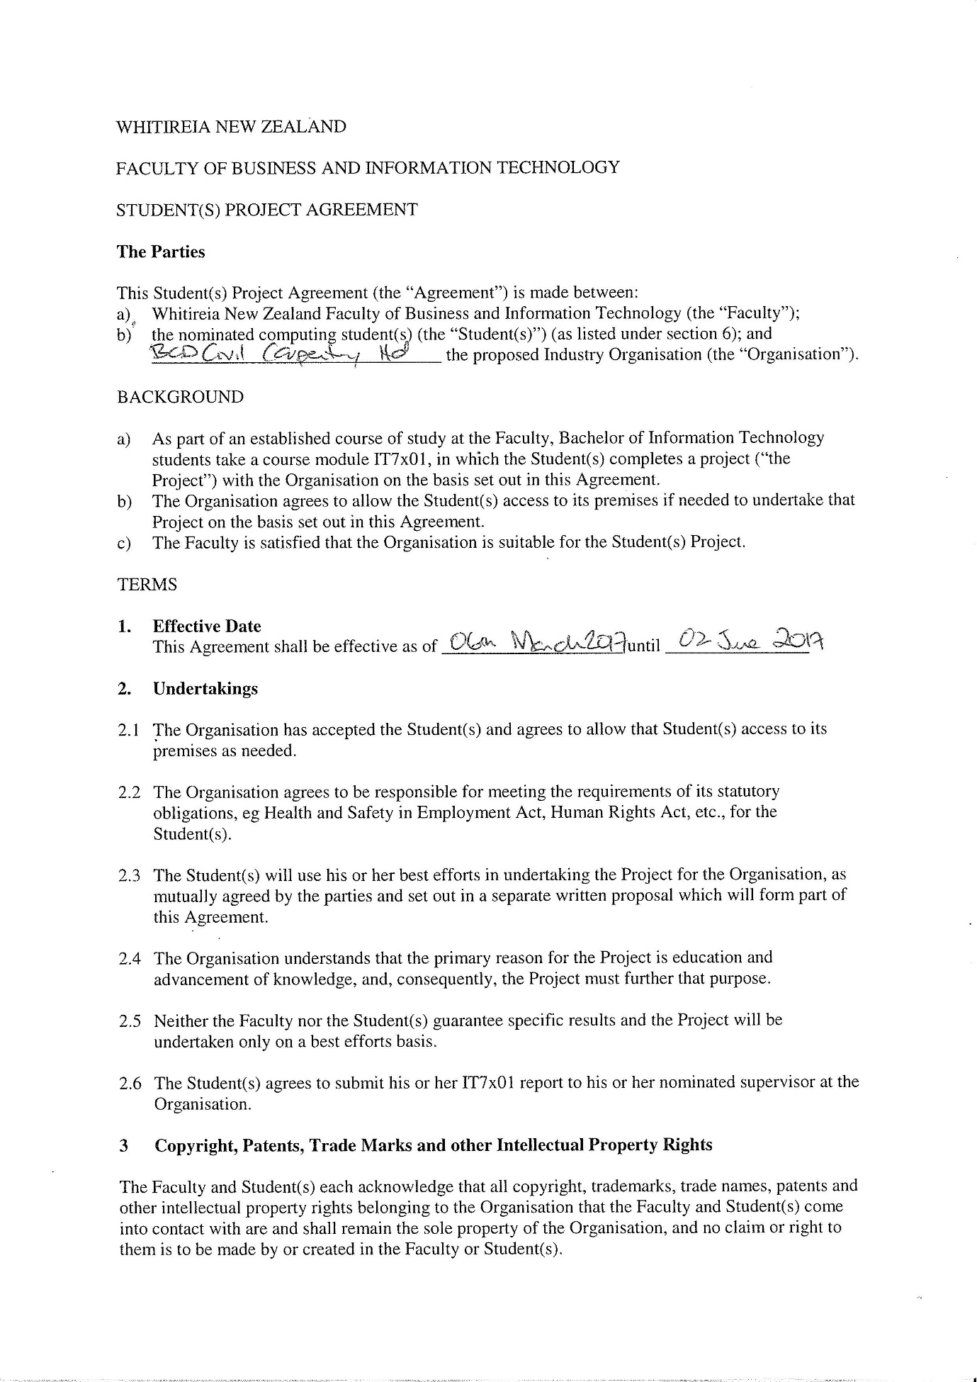

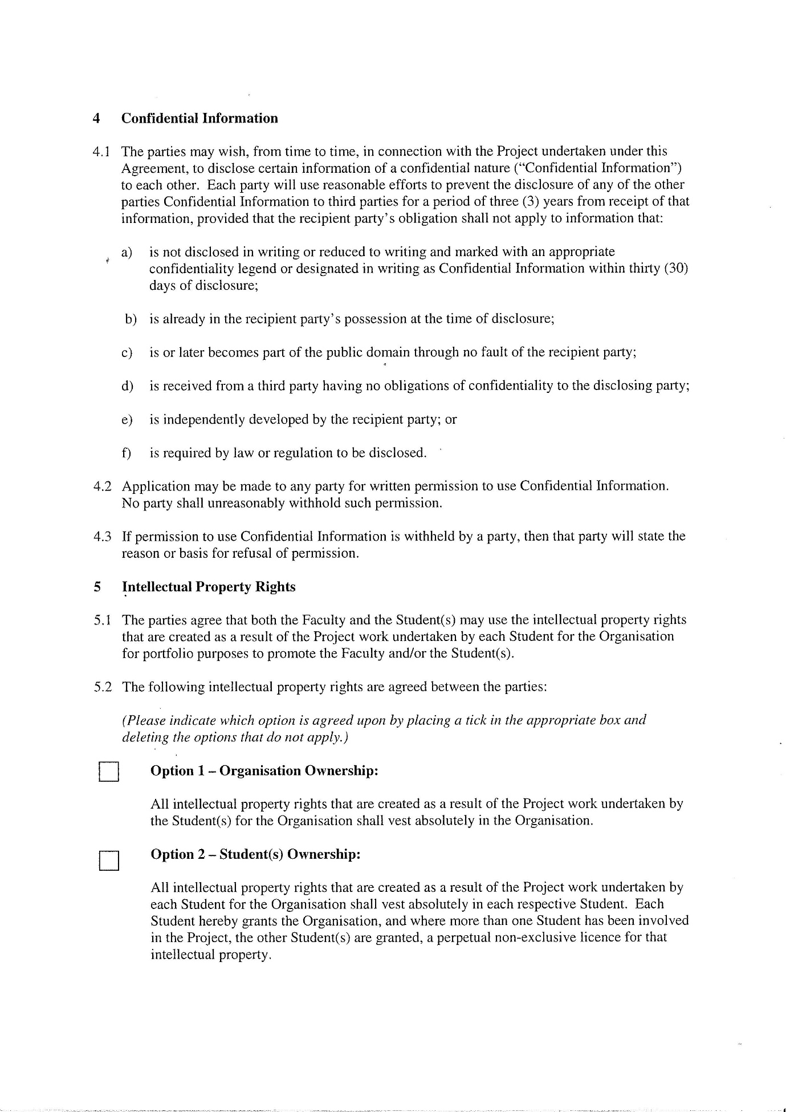

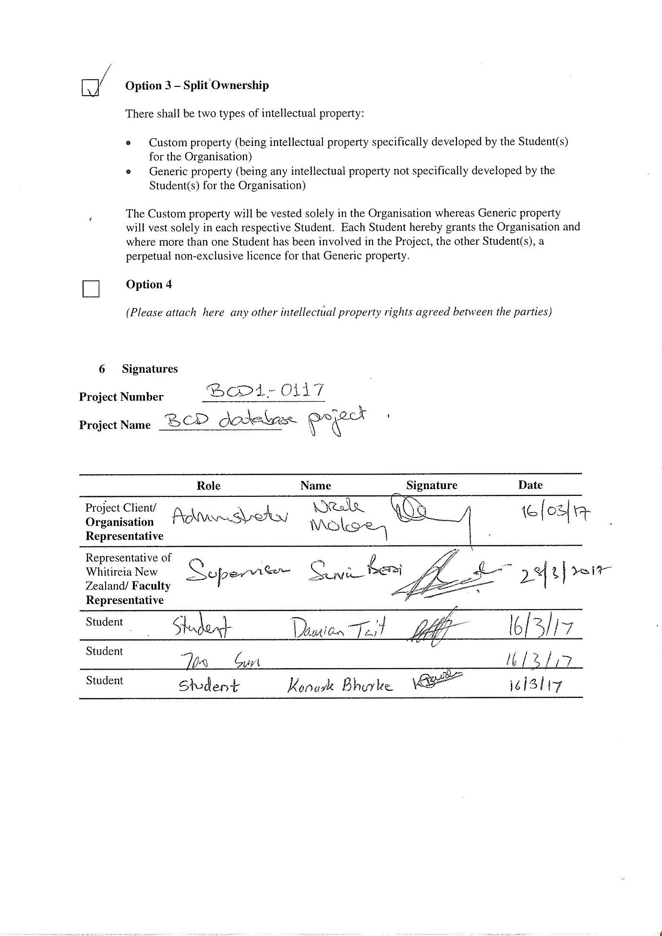

# **Group Timetable**

|  |  |  |  |  |  |  |  |
| --- | --- | --- | --- | --- | --- | --- | --- |
|  | **Monday** | **Tuesday** | **Wednesday** | **Thursday** | **Friday** | **Saturday** | **Sunday** |
| **Morning**  **9:00-11:30** | Tao  Damian  Konark | Tao  Damian  Konark | Tao  Damian  Konark | Tao  Damian  Konark | Tao  Damian  Konark | Tao  Konark | Tao  Konark |
| **Afternoon**  **13:00–17:00** | Tao  Damian  Konark | Damian  Konark | Konark | Tao  Damian  Konark | Damian | Tao  Konark | Tao  Konark |
| **Evening**  **19:00-22:00** | Damian | Tao | Damian | Tao  Damian |  | Tao |  |

Tao and Damian have class on Wednesday afternoon;

Konark has class on Friday afternoon;

Konark has work after 6:00PM every day;

Tao is looking for a part-time job. Maybe his schedule will be changed in the future.

Damian has work at weekends.